OBJECTIVE QUESTIONS

- List the different dtypes of columns in table “ball_by_ball” (using information schema)

To determine the different datatypes in the table ball_by_ball, use the below query. This query will return the column names and their corresponding data types from the ball_by_ball table, giving the required output in a simple tabular format.

Query:
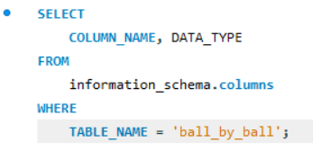

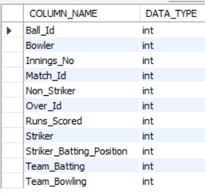
Output:

- What is the total number of runs scored in 1st season by RCB
(bonus: also include the extra runs using the extra runs table)

To determine the total runs scored by Royal Challengers Bangalore (RCB) in the inaugural IPL season, including extra runs, the following tables are essential:

Table | Purpose | Key Columns Used
ball_by_ball | Per-ball delivery data | Match_Id,Innings_No,Over_Id, Ball_Id, Team_BattingRuns_Scored
extra_runs | Extra_runs_per ball (wides, no-balls) | Match_Id,Innings_No,Over_Id, Ball_Id, Extra_Runs
matches | Match_metadata | Match_Id,Season_Id,Team_1,Team_2

Query:
WITH extra_run_data AS (
SELECT Team_Batting AS team_Id, SUM(e.Extra_Runs) as total_extra
FROM ball_by_ball b
JOIN extra_runs e ON e.Match_Id = b.Match_Id AND e.Innings_No = b.Innings_No AND e.Over_Id = b.Over_Id AND e.Ball_Id = b.Ball_IdWHERE Team_Batting = 2
AND b.Match_Id IN(
SELECT distinct Match_Id FROM matches WHERE Season_Id = ( SELECT MIN(Season_Id) as first_season FROM Matches WHERE Team_1 = 2 OR Team_2 = 2))
),
_scored_data AS ( SELECT
Team_Batting AS team_Id,SUM(b.Runs_Scored) AS total_score
FROM ball_by_ball b
JOIN matches m ON m.Match_Id = b.Match_I
WHERE Team_Batting = 2 AND (Team_1 = 2 OR Team_2 = 2) AND

m.Season_Id = ( SELECT MIN(Season_Id) as first_season FROM Matches WHERE Team_1 = 2 OR Team_2 = 2)
)
SELECT
(total_score + total_extra) AS total_runs
FROM run_scored_data s
JOIN extra_run_data e ON e.team_Id = s.team_Id;

output:
The total number of runs scored by Royal Challengers Bangalore (RCB) in the first IPL season, including extra runs, is 2601.

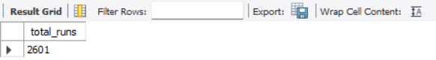

Query Strategy:
- Match Filtering: Identify the first season in which RCB (Team_Id = 2) participated by selecting the minimum Season_Id from the matches table where either Team_1 or Team_2 equals 2. Restrict all subsequent calculations to matches from this season.
- Table Joins:
  - For extras: Join ball_by_ball with extra_runs on match, innings, over, and ball identifiers to capture all extra runs conceded during RCB’s batting.
  - For runs scored: Join ball_by_ball with matches to ensure only RCB’s batting innings in their first season are included.
- Run Summation:
  - Aggregate Runs_Scored from the ball_by_ball table to compute total batting runs.
  - Aggregate Extra_Runs from the extra_runs table to compute total extras.
  - Both aggregates are grouped by Team_Batting (RCB).
- Final Output: Join the two aggregates on team_Id and add total_score + total_extra to produce the complete run tally. The result displays the total runs scored by RCB in their first IPL season, including both batting runs and extras.

3. How many players were more than age of 25 during season 2014?

To determine the number of players who were aged more than 25 during season 2

Required Tables:

Table | Purpose | Key Columns Used
Player | Stores player demographic information, including date of birth (DOB). | Player_Id, DOB
Player_Match | Links players to the matches they participated in. | Player_Id, Match_Id
Matches | Contains metadata about each match, including which season it belongs to. | Match_Id, Season_Id
Season | Defines season-level metadata such as year. | Season_Id, Season_Year

Query Strategy:

- Season Filtering Restrict matches to the 2014 season using Season.Season_Year = 2014. This ensures only players who appeared in 2014 are considered.
- Table Joins
- Player → Player_Match via Player_Id to connect players with their match appearances.
- Player_Match → Matches via Match_Id to link appearances to specific matches.
- Matches → Season via Season_Id to filter matches belonging to the 2014 season.
- Age Calculation Use TIMESTAMPDIFF(YEAR, p.DOB, m.matchdate) to compute each player’s age as of December 31, 2014. Apply the condition > 25 to filter only players older than 25.
- Distinct Player Counting Apply COUNT(DISTINCT p.Player_Id) to ensure each eligible player is counted once, even if they appeared in multiple matches during the season.
- Final Output Return a single-row table with one column (Players_Age_Above_25) showing the total number of distinct players older than 25 years in the 2014 season.

Query:
select count(distinct pm.Player_id ) as Older_Than_25
from Matches m
join Player_Match pm on m.Match_ID = pm.Match_ID
join Player p on pm.Player_Id = p.Player_Id
where m.Season_Id = 7
and timestampdiff(Year, p.DOB, m.Match_Date) > 25;
Output:

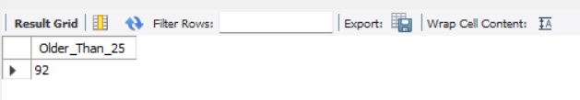

The number of players aged more than 25 during year_2014 is 92

4. How many matches did RCB win in season 2013?

To determine the number of matches won by Royal Challengers Bangalore (RCB) in the year 2013

Required Tables:

Table | Purpose | Key Columns Used
Matches | Stores match-level metadata including season, participating teams, and winner. | Match_Id, Season_Id, Match_Winner
Season | Defines season metadata such as year. | Season_Id, Season_Year
Team | Contains team information including team identifiers and names. | Team_Id, Team_Name

Query Strategy:

- Season Filtering
- Restrict matches to the 2013 season by joining the Season table and applying the condition Season_Year = 2013.
- This ensures only matches played in 2013 are considered.
- Team Identification
- Join the Team table on Match_Winner = Team_Id.
- Apply the filter Team_Name = 'Royal Challengers Bangalore' to isolate matches where RCB was the winning team.
- Winner Validation
- Include the condition Match_Winner IS NOT NULL to exclude matches without a recorded winner (e.g., abandoned or tied matches).
- Counting Matches Won
- Use COUNT(*) to count the total number of matches that meet all the above conditions.
- Alias the result as Matches_Won for clarity in reporting.

Query:
SELECT COUNT(*) AS Matches_Won
FROM Matches m
JOIN Season s ON m.Season_Id = s.Season_Id
JOIN Team t ON m.Match_Winner = t.Team_Id
WHERE s.Season_Year = 2013
AND t.Team_Name = 'Royal Challengers Bangalore'
AND m.Match_Winner IS NOT NULL;

Output:
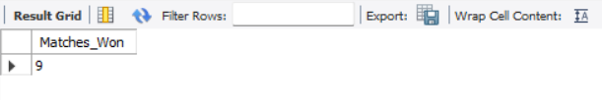

The number of matches RCB won in 2013 is 9.

5. List the top 10 players according to their strike rate in last 4 seasons

To identify the top 10 players based on their strike rate over the last four seasons:
Required Tables:
- player: Contains player details, including their names and IDs.
- ball_by_ball: Tracks each ball bowled, including the batsman on strike.
- matches: Contains match details, linking players to matches.
- season: Stores information about different seasons of the tournament.
Query Strategy:
- Strike Rate Calculation: Calculate the strike rate for each player as the total runs scored divided by the total balls faced, multiplied by 100.
- Match Filtering: Focus on matches from the last four seasons (Season IDs 6, 7, 8, and 9).
- Join Tables: Join the necessary tables to link players with their performances in matches.
- Row Ranking: Rank players based on their calculated strike rate in descending order.
- Select Top Players: Retrieve the top 10 players based on their strike rates.

Query:

WITH Last_4_Seasons AS (
SELECT Season_Year FROM Season ORDER BY Season_Year DESC LIMIT 4
),
Striker_Rate AS (
SELECT
B.Striker,
ROUND((SUM(B.Runs_Scored) / NULLIF(COUNT(B.Ball_Id), 0)) * 100, 2) AS Strike_Rate
FROM Ball_by_Ball B
JOIN Matches M ON B.Match_Id = M.Match_Id
JOIN Season S ON M.Season_Id = S.Season_Id
JOIN Last_4_Seasons L4S ON S.Season_Year = L4S.Season_Year
GROUP BY B.Striker
HAVING COUNT(B.Ball_Id) > 100
)
SELECT
RANK() OVER (ORDER BY SR.Strike_Rate DESC) AS Ranking,
P.Player_Name,
SR.Strike_Rate
FROM Striker_Rate SR
JOIN Player P ON SR.Striker = P.Player_Id
ORDER BY SR.Strike_Rate DESC
LIMIT 10;

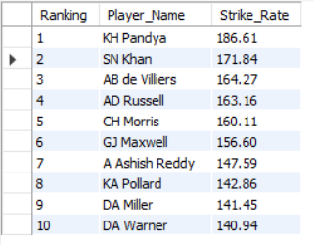
Output:

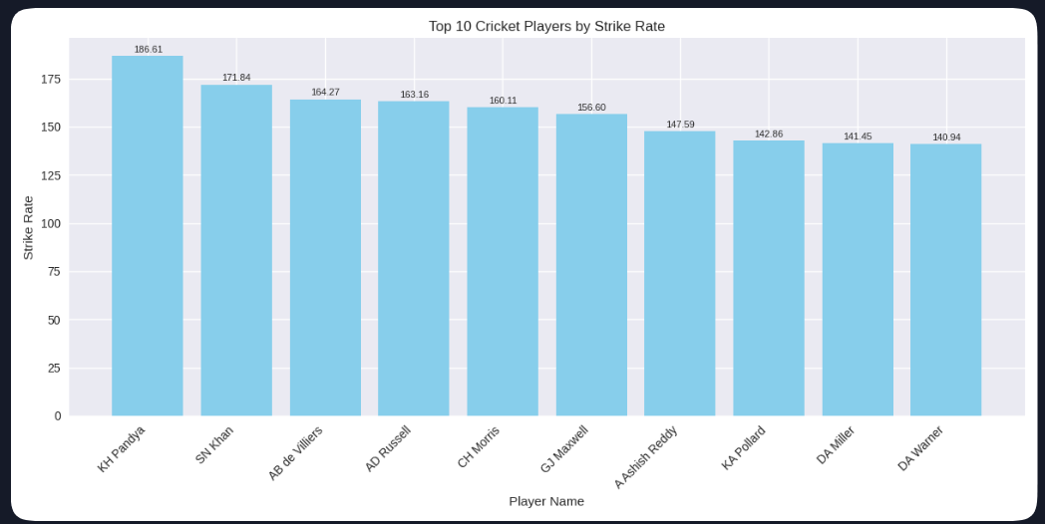

6. What are the average runs scored by each batsman considering all the seasons?

To calculate the average runs scored by each batsman across all seasons, including total runs and innings played.

Required Tables:

Table Name | Purpose | Key Columns Used
Ball_by_Ball | Stores ball-level data for each match, including runs scored, striker, match, and innings identifiers. | Runs_Scored,Striker, Match_Id, Innings_No
Player | Contains player metadata such as player IDs and names. Used to map striker IDs to readable names. | Player_Id, Player_Name

Query Strategy:

- Summing Total Runs: For each batsman, the total runs scored are summed across all matches.
- Innings Count: Distinct matches are counted as innings to represent the number of innings each batsman played.
- Average Calculation: The average runs are calculated by dividing the total runs scored by the number of innings played for each batsman.
- Order Results: The query returns batsman names, their average runs.

Query:

SELECT
p.Player_Name,
SUM(COALESCE(b.Runs_Scored, 0)) AS Total_Runs,
COUNT(DISTINCT CONCAT(b.Match_Id, '-', b.Innings_No)) AS Innings_Played,
ROUND(SUM(COALESCE(b.Runs_Scored, 0)) / NULLIF(COUNT(DISTINCT CONCAT(b.Match_Id, '-', b.Innings_No)), 0), 2) AS Avg_Runs
FROM Ball_by_Ball b
JOIN Player p ON b.Striker = p.Player_Id
GROUP BY p.Player_Name
ORDER BY Avg_Runs DESC;

Output:

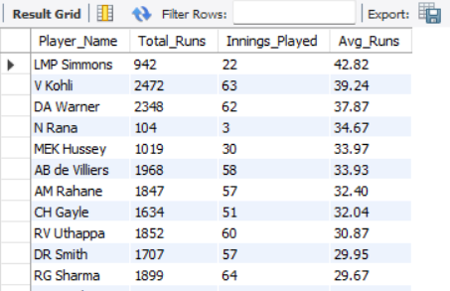

7. What are the average wickets taken by each bowler considering all the seasons?

The query calculates the average number of wickets taken per match for each bowler across all IPL seasons.

Query Strategy:

- Aggregating Wickets: For each bowler, calculate the total number of wickets by counting the number of times a wicket was taken (wt.Player_Out).
- Calculating Matches Played: Count the distinct matches the bowler played in, using DISTINCT on ball.Match_Id.
- Average Wickets Calculation: Divide the total wickets by the number of matches played to get the average wickets per match for each bowler.
- Ranking: Rank the bowlers based on their average wickets in descending order.

Required Tables:

Table Name | Purpose | Key Columns Used
Player | Contains details about each player, including their ID and name. | Player_Id, Player_Name
Ball_by_Ball | Tracks every ball bowled, including the bowler for each delivery. | Match_Id, Innings_No, Over_No, Ball_No, Bowler, Striker, Runs_Scored
Wicket_Taken | Stores information about each wicket, including which ball, over, and match the wicket was taken in. | Match_Id, Innings_No, Over_No, Ball_No, Player_Out, Dismissal_Type

Query:

WITH wickets_per_bowler_season AS (
SELECT
b.Bowler,
m.Season_Id,
COUNT(w.Player_Out) AS wickets_taken
FROM ball_by_ball b
JOIN wicket_taken w
ON b.Match_Id = w.Match_Id
AND b.Over_Id = w.Over_Id
AND b.Ball_Id = w.Ball_Id
AND b.Innings_No = w.Innings_No
JOIN Matches m
ON m.Match_Id = w.Match_Id
GROUP BY b.Bowler, m.Season_Id
),
avg_per_bowler AS (
SELECT
Bowler,
AVG(wickets_taken) AS avg_wicket_per_bowler
FROM wickets_per_bowler_season
GROUP BY Bowler
)
SELECT
p.Player_Name,
ROUND(apb.avg_wicket_per_bowler, 2) AS Avg_wicket,
RANK() OVER (ORDER BY apb.avg_wicket_per_bowler DESC) AS rnk
FROM avg_per_bowler apb
JOIN Player p
ON p.Player_Id = apb.Bowler
WHERE apb.avg_wicket_per_bowler > 0
ORDER BY rnk, p.Player_Name;

Output:

This query will return the average wickets taken by each bowler across all seasons, ranked in descending order. The output will display the following
    - Rank: The rank based on average wickets per match.
    - Player_Name: The name of the bowler.
    - Average_Wickets: The calculated average number of wickets taken per match for each player.
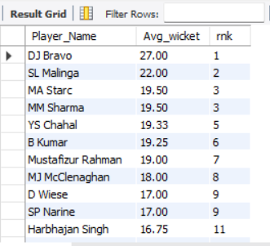
Since the query will return the average wickets for all players, it may be too extensive to include the entire output in a report. To make the data more concise and relevant, only the top 10 records are attached for the result.

8. List all the players who have average runs scored greater than overall average and who have taken wickets greater than overall average

This query aims to identify players who exceed both the average runs scored and the average wickets taken across all players in the dataset. It calculates individual averages and then compares them to the overall averages, providing a list of top-performing players in both batting and bowling.

Required Tables:

Table Name | Purpose | Key Column(s) Used
Ball_by_Ball | Stores ball-level match data including runs scored, wickets taken, striker, and bowler. | Ball_Id (primary key), Striker, Bowler
Player | Master data for all players, providing player identifiers and names. | Player_Id (primary key), Player_Name
Player_Avg_Runs (CTE) | Derived table calculating batting stats per player: total runs, balls faced, average runs. | Player_Id
Player_Avg_Wickets (CTE) | Derived table calculating bowling stats per player: total wickets, balls bowled, average wickets. | Player_Id
Overall_Avg (CTE) | Derived table calculating overall average runs and wickets across all players. | No key column (aggregated dataset)

Query Strategy:

- Aggregating Runs: Calculate the average runs per match for each batsman by summing the runs scored and dividing by the distinct number of matches played.
- Aggregating Wickets: For each bowler, calculate the total number of wickets by counting the occurrences of wt.Player_Out, which indicates a wicket taken.
- Calculating Matches Played: Count the distinct matches each bowler participated in by using DISTINCT on ball.Match_Id.
- Average Wickets Calculation: Divide the total wickets taken by the number of matches played to derive the average wickets per match for each bowler.
- Overall Averages Calculation: Compute the overall averages for both runs and wickets across all players to serve as a benchmark for comparison.
- Filtering Players: Select players whose average runs scored exceeds the overall average runs and whose total wickets taken surpass the overall average wickets.

The average runs scored is greater than the overall average:

Query:

WITH Player_Avg_Runs AS (
SELECT
bb.Striker AS Player_Id,
p.Player_Name,
COUNT(bb.Ball_Id) AS Balls_Faced,
SUM(bb.Runs_Scored) AS Total_Runs,
SUM(bb.Runs_Scored) * 1.0 / NULLIF(COUNT(bb.Ball_Id), 0) AS Avg_Runs
FROM Ball_by_Ball bb
JOIN Player p ON bb.Striker = p.Player_Id
GROUP BY bb.Striker, p.Player_Name
),

Player_Wickets AS (
SELECT
wt.Player_Out AS Player_Id,
p.Player_Name,
COUNT(*) AS Total_Wickets
FROM Wicket_Taken wt
JOIN Player p ON wt.Player_Out = p.Player_Id
GROUP BY wt.Player_Out, p.Player_Name
),

Overall_Avg AS (
SELECT SUM(Runs_Scored) * 1.0 / NULLIF(COUNT(Ball_Id), 0) AS Overall_Avg_Runs
FROM Ball_by_Ball
),

Overall_Wickets AS (
SELECT AVG(Total_Wickets) AS Overall_Avg_Wickets
FROM (
SELECT COUNT(*) AS Total_Wickets
FROM Wicket_Taken
GROUP BY Player_Out
) AS Wicket_Data
),

Combined AS (
SELECT
a.Player_Id,
a.Player_Name,
a.Total_Runs,
a.Avg_Runs,
COALESCE(w.Total_Wickets, 0) AS Total_Wickets
FROM Player_Avg_Runs a
LEFT JOIN Player_Wickets w ON a.Player_Id = w.Player_Id
),

Overall AS (
SELECT oa.Overall_Avg_Runs, ow.Overall_Avg_Wickets
FROM Overall_Avg oa
CROSS JOIN Overall_Wickets ow
)

SELECT
RANK() OVER (ORDER BY c.Avg_Runs DESC) AS player_rank,
c.Player_Id,
c.Player_Name,
ROUND(c.Avg_Runs, 2) AS avg_per_match,
c.Total_Wickets AS total_wicket
FROM Combined c
CROSS JOIN Overall o
WHERE c.Avg_Runs > o.Overall_Avg_Runs
AND c.Total_Wickets > o.Overall_Avg_Wickets
ORDER BY player_rank;

Output:
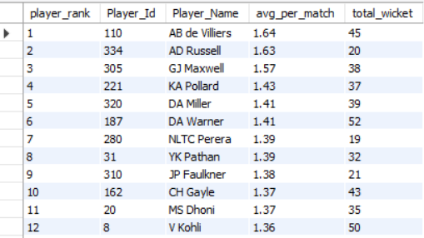

9. Create a table rcb_record table that shows wins and losses of RCB in an individual venue.

Required Tables:

Table Name | Purpose | Key Column(s) Used
matches | Stores match details, including participating teams, venue, and match winner. | Match_Id (primary key), Team_1, Team_2, Venue_Id, Match_Winner
team | Provides team master data with team names and IDs. | Team_Id (primary key), Team_Name
venue | Contains venue details such as venue names and IDs. | Venue_Id (primary key), Venue_Name

Query Strategy:
- Filter for RCB Matches: Select matches where either Team_1 or Team_2 is "Royal Challengers Bangalore" by joining with the team table.
- Aggregate Matches by Venue: For each venue, count the total number of matches played by RCB.
- Calculate Wins and Losses:
  - Wins: Count matches where the winning team is RCB.
  - Losses: Count matches where RCB participated but did not win.
- Calculate No Result (NR): Subtract the sum of wins and losses from total matches to determine the number of "no result" matches for RCB at each venue.
Output: Display the venue name, total matches, wins, losses, and no result (NR) matches

Query:
WITH rcb_record AS (
SELECT
v.Venue_Name,
COUNT(*) AS Total_Matches,
SUM(CASE WHEN m.Match_Winner = t.Team_Id THEN 1 ELSE 0 END) AS Wins,
SUM(CASE WHEN m.Match_Winner != t.Team_Id AND (m.Team_1 = t.Team_Id OR m.Team_2 = t.Team_Id) THEN 1 ELSE 0 END) AS Loses
FROM matches m
INNER JOIN team t ON (t.Team_Name = 'Royal Challengers Bangalore')
INNER JOIN venue v ON m.Venue_Id = v.Venue_Id
WHERE (m.Team_1 = t.Team_Id OR m.Team_2 = t.Team_Id)
GROUP BY v.Venue_Name)

SELECT Venue_Name,Total_Matches,Wins,Loses, (Total_Matches - (Wins + Loses)) as NR FROM rcb_record;

Output:

The query will output the following columns:
- Venue_Name: The name of each venue where RCB has played.
- Total_Matches: The total number of matches RCB played at each venue.
- Wins: The number of matches won by RCB at each venue.
- Loses: The number of matches lost by RCB at each venue.
- NR: The count of "no result" matches for RCB at each venue, calculated as matches that were neither wins nor losses.
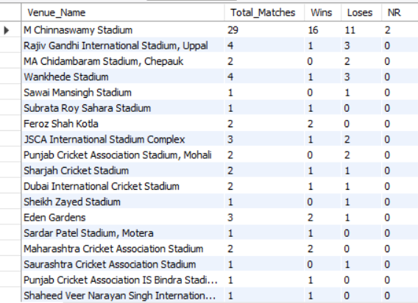

10. What is the impact of bowling style on wickets taken.

Required Tables:

Table Name | Purpose | Key Column(s) Used
player | Contains details of players, including their bowling skills. | Player_Id (primary key), Bowling_Style_Id (foreign key)
bowling_style | Provides the types of bowling skills, with a unique ID for each style. | Bowling_Style_Id (primary key), Bowling_Style_Name
ball_by_ball | Contains data on each ball bowled in a match, including the bowler’s ID. | Ball_Id (primary key), Bowler_Id (foreign key to Player)
wicket_taken | Records details of each wicket taken, including dismissal type and bowler involved. | Wicket_Id (primary key), Bowler_Id (foreign key to Player), Dismissal_Type

Query Strategy:
- Filter for Bowler Wickets: Join the player table with bowling_style to access each bowler's skill.
- Exclude Run-Outs: Restrict the data to dismissals where Kind_Out is not equal to 3, which represents run-outs.
- Count Wickets per Bowling Style:
  - Count the total number of wickets taken for each bowling skill by joining the ball_by_ball table with the wicket_taken table.
- Order by Wickets Taken: Sort the results in descending order to highlight the most effective bowling styles.

Query:

SELECT bs.Bowling_skill, COUNT(wt.Player_Out) AS Wickets_Taken
FROM player p
INNER JOIN bowling_style bs ON p.Bowling_skill = bs.Bowling_Id
INNER JOIN ball_by_ball ball ON p.Player_Id = ball.Bowler
INNER JOIN wicket_taken wt ON ball.Match_Id = wt.Match_Id AND ball.Over_Id = wt.Over_Id AND ball.Ball_Id = wt.Ball_Id
WHERE wt.Kind_Out <> 3 -- Removing Run Outs
GROUP BY bs.Bowling_skill

ORDER BY Wickets_Taken DESC;

Output:
The query will return the following columns:
- Bowling_skill: The type of bowling style (e.g., spin, fast).
- Wickets_Taken: The total number of wickets taken by players with each bowling style, ranked in descending order.
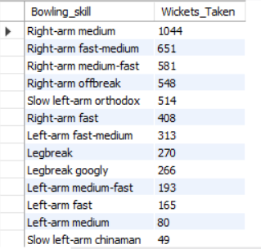

11. Write the sql query to provide a status of whether the performance of the team better than the previous year performance on the basis of number of runs scored by the team in the season and number of wickets taken.

Required Tables:

Table Name | Purpose | Key Column(s) Used
Ball_by_Ball | Stores ball-level match data including runs scored per ball. Used to calculate total runs per match/innings. | Ball_Id (primary key), Match_Id, Innings_No, Runs_Scored
Matches | Contains match details such as teams, toss decision, toss winner, and season. Used to attribute runs/wickets to Team_Id = 2 correctly. | Match_Id (primary key), Team_1, Team_2, Toss_Winner, Toss_Decide, Season_Id
Wicket_Taken | Records details of each wicket, including dismissal type and player out. Used to calculate total wickets per match/innings. | Wicket_Id (primary key), Match_Id, Innings_No, Player_Out, Bowler_Id
Season | Master table for seasons. Ensures results are grouped season-wise and provides season identifiers. | Season_Id (primary key)
total_run_match_id (CTE) | Derived table: total runs per match per innings. Built from Ball_by_Ball. | Match_Id, Innings_No
total_runs_per_season (CTE) | Derived table: aggregates total runs per season for Team_Id = 2 using toss logic. | Season_Id
total_wickets_per_match_innings (CTE) | Derived table: total wickets per match per innings. Built from Wicket_Taken. | Match_Id, Innings_No
total_wickets_per_season (CTE) | Derived table: aggregates total wickets per season for Team_Id = 2 using toss logic. | Season_Id

Query Strategy:
- Team Performance Calculation: Created a Common Table Expression (CTE) named TeamPerformance to summarize each team's performance per season. For each team and season, calculated the total runs scored and total wickets taken.
  - Joined team, player_match, and matches tables to gather each team's seasonal match data.
  - Aggregated the runs scored using a subquery on batsman_scored, totalling up the runs per match and joining it with the matches table.
  - Counted total wickets using a subquery on wicket_taken, excluding cases where no player was out.
- Comparing Year-on-Year Performance:
  - Using the TeamPerformance CTE, matched each team's performance data from one year with the subsequent year using a self-join, linking records by Team_Name and consecutive Season_Year.
  - For each year-to-year comparison, identified whether the team’s performance was "Better” or "Worse" based on both runs scored and wickets taken.
- Performance Status Evaluation:
  - Established a CASE statement to set the Performance_Status field, defining performance improvements by comparing runs and wickets across years. The conditions are:
    - "Better" if both runs and wickets increased.
    - "Worse" if both values decreased.
  - Sorted the output by Team_Name and Season_Year for clear chronological reporting.

Query:
WITH total_run_match_id AS (
-- Total runs per innings per match
SELECT
bb.Match_Id,
bb.Innings_No,
SUM(bb.Runs_Scored) AS total_runs
FROM Ball_by_Ball bb
GROUP BY bb.Match_Id, bb.Innings_No
),

team_runs_per_season AS (
-- Total runs per season for each team
SELECT
m.Season_Id,
t.Team_Id,
t.Team_Name,
SUM(
CASE
WHEN m.Toss_Decide = 1 AND m.Toss_Winner = t.Team_Id AND tr.Innings_No = 2 THEN tr.total_runs
WHEN m.Toss_Decide = 2 AND m.Toss_Winner = t.Team_Id AND tr.Innings_No = 1 THEN tr.total_runs
WHEN m.Toss_Decide = 1 AND m.Toss_Winner <> t.Team_Id AND tr.Innings_No = 1 THEN tr.total_runs
WHEN m.Toss_Decide = 2 AND m.Toss_Winner <> t.Team_Id AND tr.Innings_No = 2 THEN tr.total_runs
ELSE 0
END
) AS total_runs
FROM total_run_match_id tr
JOIN Matches m ON tr.Match_Id = m.Match_Id
JOIN Team t ON t.Team_Id IN (m.Team_1, m.Team_2)
GROUP BY m.Season_Id, t.Team_Id, t.Team_Name
),

team_wickets_per_match_innings AS (
-- Total wickets per match per innings
SELECT
w.Match_Id,
w.Innings_No,
COUNT(w.Player_Out) AS total_wickets
FROM Wicket_Taken w
GROUP BY w.Match_Id, w.Innings_No
),

team_wickets_per_season AS (
-- Total wickets per season for each team
SELECT
m.Season_Id,
t.Team_Id,
t.Team_Name,
SUM(
CASE
WHEN m.Toss_Decide = 1 AND m.Toss_Winner = t.Team_Id AND tw.Innings_No = 1 THEN tw.total_wickets
WHEN m.Toss_Decide = 2 AND m.Toss_Winner = t.Team_Id AND tw.Innings_No = 2 THEN tw.total_wickets
WHEN m.Toss_Decide = 1 AND m.Toss_Winner <> t.Team_Id AND tw.Innings_No = 2 THEN tw.total_wickets
WHEN m.Toss_Decide = 2 AND m.Toss_Winner <> t.Team_Id AND tw.Innings_No = 1 THEN tw.total_wickets
ELSE 0
END
) AS total_wickets
FROM team_wickets_per_match_innings tw
JOIN Matches m ON m.Match_Id = tw.Match_Id
JOIN Team t ON t.Team_Id IN (m.Team_1, m.Team_2)
GROUP BY m.Season_Id, t.Team_Id, t.Team_Name
),

team_season_summary AS (
-- Combined runs and wickets per team per season
SELECT
r.Team_Id,
r.Team_Name,
r.Season_Id,
r.total_runs,
COALESCE(w.total_wickets, 0) AS total_wickets
FROM team_runs_per_season r
LEFT JOIN team_wickets_per_season w
ON w.Team_Id = r.Team_Id AND w.Season_Id = r.Season_Id
)

-- Final year-over-year comparison
SELECT
curr.Team_Name,
(prev.Season_Id + 2007) AS Previous_Year,
(curr.Season_Id + 2007) AS Current_Year,
prev.total_runs AS Previous_Runs,
curr.total_runs AS Current_Runs,
prev.total_wickets AS Previous_Wickets,
curr.total_wickets AS Current_Wickets,
CASE
WHEN curr.total_runs > prev.total_runs AND curr.total_wickets > prev.total_wickets THEN 'Better'
WHEN curr.total_runs < prev.total_runs AND curr.total_wickets < prev.total_wickets THEN 'Worse'
ELSE 'Mixed'
END AS Performance_Status
FROM team_season_summary curr
JOIN team_season_summary prev
ON prev.Team_Id = curr.Team_Id
AND prev.Season_Id = curr.Season_Id - 1
ORDER BY curr.Team_Name, curr.Season_Id;

Output:
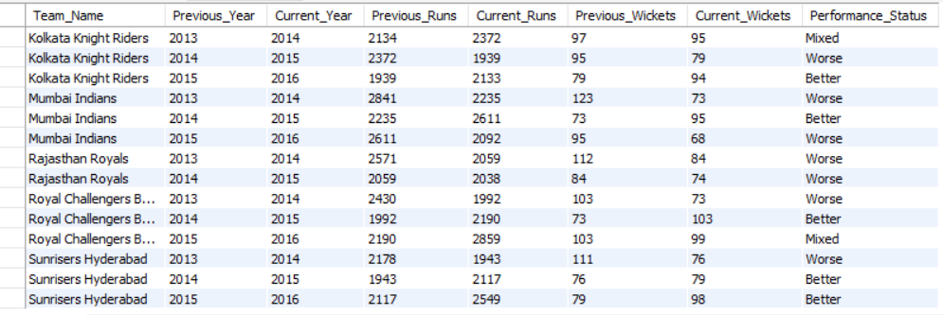

🏏 RCB Performance Breakdown

Season Transition | Runs Change | Wickets Change | Status
2013 → 2014 | ↓ 2430 → 1992 | ↓ 109 → 73 | Worse
2014 → 2015 | ↑ 1992 → 2190 | ↑ 73 → 103 | Better
2015 → 2016 | ↑ 2190 → 2859 | ↓ 103 → 99 | Mixed

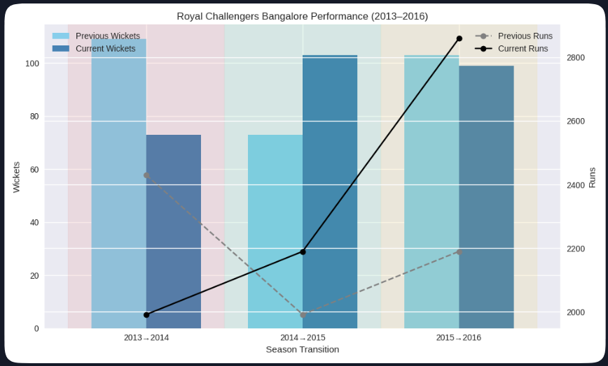

12. Can you derive more KPIs for the team strategy if possible?

KPI #1 - Boundary Percentage:
- Calculates the percentage of fours and sixes hit by each player.
- Helps analyze aggressive batting strategies.
- Sports players by six-hitting ability, followed by fours.
Query:
SELECT pm.Player_Id, p.Player_Name,
ROUND((SUM(CASE WHEN b.Runs_Scored = 4 THEN 1 ELSE 0 END) / COUNT(*)) * 100, 2) AS Four_Percentage,
ROUND((SUM(CASE WHEN b.Runs_Scored = 6 THEN 1 ELSE 0 END) / COUNT(*)) * 100, 2) AS Six_Percentage
FROM Ball_by_Ball b
JOIN Matches m
ON m.Match_Id = b.Match_Id
JOIN Player_Match pm
ON m.Match_Id = pm.Match_Id AND pm.Player_Id = b.Striker
JOIN Player p
ON pm.Player_Id = p.Player_Id
WHERE m.Season_Id IN (SELECT DISTINCT Season_Id FROM Matches WHERE Team_1 = 2 OR Team_2 = 2)
GROUP BY pm.Player_Id, p.Player_Name
ORDER BY Six_Percentage DESC, Four_Percentage DESC
LIMIT 15;

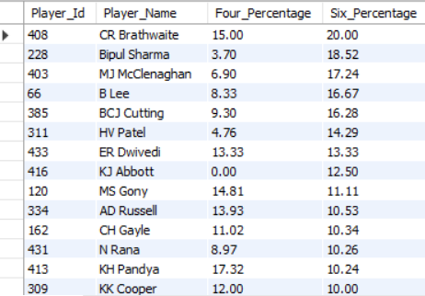
Output:
Overview
This table presents boundary-hitting efficiency for a set of players, focusing on:
- Four_Percentage: % of scoring shots that are fours (4 runs)
- Six_Percentage: % of scoring shots that are sixes (6 runs)
These metrics help evaluate a player's boundary-hitting style—whether they rely more on ground shots (fours) or power-hitting (sixes)—which is crucial for shaping RCB’s batting strategy across different match situations.

Key Observations

Player_Name | Four % | Six % | Summary
KH Pandya | 17.32 | 10.24 | High four rate, balanced hitter
CR Brathwaite | 15.00 | 20.00 | Explosive six-hitter, ideal finisher
Bipul Sharma | 3.70 | 18.52 | Low four %, six-focused hitter
MJ McClenaghan | 6.90 | 17.24 | Power-hitter, good for lower order
B Lee | 8.33 | 16.67 | Aggressive boundary scorer
BCJ Cutting | 9.30 | 16.28 | Versatile, boundary-capable
HV Patel | 4.76 | 14.29 | Lower-order pinch hitter
ER Dwivedi | 13.33 | 13.33 | Balanced boundary profile
KJ Abbott | 0.00 | 12.50 | Pure six-hitter, no ground shots
MS Gony | 14.81 | 11.11 | Strong four-hitter, middle overs
AD Russell | 13.93 | 10.53 | Reliable boundary mix, finisher
CH Gayle | 11.02 | 10.34 | Classic six-hitter, consistent
N Rana | 8.97 | 10.26 | Moderate boundary scorer
KK Cooper | 12.00 | 10.00 | Balanced, lower-order option
GJ Maxwell | 13.04 | 9.61 | Creative hitter, middle overs anchor

Strategic Recommendations for RCB

- Power Finishers: CR Brathwaite, AD Russell, and MJ McClenaghan stand out as explosive hitters in the death overs. Their high six percentages make them ideal for accelerating the run rate when boundaries are crucial.
- Middle-Order Stability: KH Pandya and MS Gony provide strong four-hitting ability, ensuring steady strike rotation and momentum building in the middle overs. They can anchor the innings while keeping the scoreboard ticking.
- Versatile Options: BCJ Cutting and CH Gayle offer a balanced mix of fours and sixes. Their adaptability makes them valuable in flexible roles, whether stabilizing the innings or shifting gears into aggressive play.
- Avoid Low Four % Players: Bipul Sharma and KJ Abbott rely heavily on six-hitting but lack ground stroke efficiency. On slower pitches, where fours are more effective, they may struggle to maintain consistency.

Role-Based Lineup Suggestion

Role | Player Options
Opener | KH Pandya, CH Gayle
Middle Order | Maxwell, MS Gony, AD Russell
Finisher | Brathwaite, Cutting, McClenaghan
Floater | Bipul Sharma (death overs only)

KPI #2 - Bowling Strike Rate (Lower is Better):
- Measures the number of balls bowled per wicket taken.
- Helps identify effective bowlers who take wickets quickly.
- Filters for RCB bowlers and ranks them in ascending order.

Query:
SELECT bb.Bowler, p.Player_Name,
ROUND(COUNT(bb.Ball_Id) / COUNT(w.Player_Out),2) AS Strike_Rate
FROM ball_by_ball bb
LEFT JOIN wicket_taken w
ON bb.Match_Id = w.Match_Id
AND bb.Over_Id = w.Over_Id
AND bb.Ball_Id = w.Ball_Id
JOIN player p
ON p.Player_Id = bb.Bowler
WHERE bb.Team_Bowling = 2
GROUP BY bb.Bowler
HAVING Strike_Rate IS NOT NULL
ORDER BY Strike_Rate ASC
LIMIT 15;

Output:
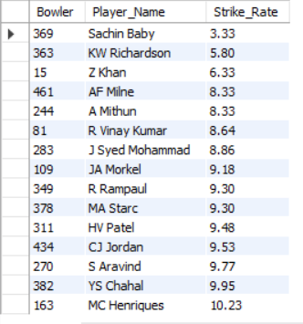

RCB Auction Strategy – Bowler Selection Based on Strike Rate
- Strike Rate = Balls bowled per wicket taken
- Lower strike rate = More frequent wickets
- In T20, this is crucial for breaking partnerships and shifting momentum quickly.
Powerplay Specialists (Overs 1–6)
Objective: Take early wickets to destabilise the opposition’s top order.
Top Targets:
- Sachin Baby (3.33) – Surprisingly elite strike rate; could be a hidden gem if used tactically.
- KW Richardson (5.80) – Proven new-ball bowler with consistent early breakthroughs.
- Z Khan (6.33) – Veteran with control and swing, ideal for early overs.
Why Important: Early wickets reduce scoring freedom and force the opposition to rebuild under pressure.

Middle Overs Enforcers (Overs 7–15)
Objective: Control the game, break partnerships, and maintain pressure.
Top Picks:
- AF Milne / A Mithun (8.33) – Both offer pace and wicket-taking ability, good for rotation.
- R Vinay Kumar (8.64) – Experienced domestic bowler, useful on Indian pitches.
- J Syed Mohammad (8.86) – Spin option, ideal for choking runs and inducing mistakes.
Why Important: Middle overs often decide momentum. These bowlers can slow run rate and grab key wickets.

Death Overs Specialists (Overs 16–20)
Objective: Prevent big finishes, take wickets, and execute yorkers or slower balls.
Top Picks:
- MA Starc / R Rampaul (9.30) – Left-arm pace, excellent for death overs with swing and variation.
- CJ Jordan (9.53) – Known for death-over control and yorkers.
- HV Patel / S Aravind (~9.5) – Familiar with RCB setup, reliable under pressure.
Why Important: Death overs are high-risk. These bowlers can contain runs and take wickets when batsmen go hard.

Spin Control Option
- YS Chahal (9.95) – Smart spinner, great for middle overs and match-ups against aggressive batsmen.
Why Important: Spin adds variety and is effective on slower pitches, especially in Indian conditions.

Use Selectively
- MC Henriques (10.23) – More of a batting all-rounder; not a strike bowler. Use only for balance or backup.

Role-Based Auction Blueprint
Role | Recommended Bowlers
Powerplay Attack | Sachin Baby, KW Richardson, Z Khan
Middle Overs | Milne, Mithun, Vinay Kumar, Syed Mohammad
Death Overs | Starc, Jordan, Rampaul, HV Patel
Spin Matchups | YS Chahal
All-Round Depth | JA Morkel, Henriques (support roles)

Final Strategy for RCB
- Mix experience with strike efficiency: Blend veterans like Z Khan and Starc with emerging options like Milne and Baby.
- Prioritize role clarity: Don’t overload one phase—ensure coverage across powerplay, middle, and death overs.
- Adapt to pitch conditions: On slower pitches, spin and control bowlers like Chahal and Syed Mohammad become more valuable.
- Auction smart: Focus on strike rate, but also consider match-ups, economy, and adaptability.

13. Using SQL, write a query to find out average wickets taken by each bowler in each venue. Also rank the gender according to the average value.

To generate a report that shows the average wickets taken by each bowler at each venue. Additionally, rank the bowlers based on their average wickets per match in descending order.

Table Name | Purpose | Key Columns Used
player | Stores player details for identification and linking with match events. | Player_Id , Player_Name
ball_by_ball | Captures every delivery bowled in matches, linking bowler and match context. | Bowler(Player_Id), Match_Id, Over_Id, Ball_Id
matches | Holds match-level information including venue reference. | Match_Id , Venue_Id
wicket_taken | Records wickets taken, identifying when and who was dismissed. | Match_Id, Over_Id, Ball_Id, Player_Out
venue | Stores venue details for matches. | Venue_Id , Venue_Name

Query Strategy:
- Calculate Average Wickets per Venue:
- Created a Common Table Expression (CTE) named AvgWicketsPerVenue to calculate the average wickets taken by each bowler at each venue.
- Joined tables to get relevant data for each bowler, match, and venue.
- Used COUNT(wt.Player_Out) to calculate the total wickets taken by each bowler at each venue.
- Used COUNT(DISTINCT m.Match_Id) to calculate the total matches each bowler played at each venue.
- Calculated Avg_Wickets as the ratio of total wickets to total matches per bowler per venue.
- Assign Ranking:
- In the main query, applied the RANK() window function to assign a rank based on the Avg_Wickets for each bowler, in descending order, across all venues.
- Sorted the output by Wicket_Rank for easy readability.

Query:

WITH player_wickets AS (
SELECT v.Venue_Id, v.Venue_Name,
p.Player_Name,
COUNT(w.Player_Out) AS total_wickets,
COUNT(DISTINCT m.Match_Id) AS matches_played -- Distinct matches where the player bowled
FROM Wicket_Taken w
JOIN Ball_by_Ball b
ON w.Match_Id = b.Match_Id
AND w.Over_Id = b.Over_Id
AND w.Ball_Id = b.Ball_Id
AND w.Innings_No = b.Innings_No -- Ensuring correct innings mapping
JOIN Matches m
ON b.Match_Id = m.Match_Id
JOIN Player_Match pm
ON pm.Match_Id = m.Match_Id
AND pm.Player_Id = b.Bowler -- Ensuring only actual bowlers are counted
JOIN Player p
ON p.Player_Id = pm.Player_Id
JOIN Venue v
ON v.Venue_Id = m.Venue_Id
GROUP BY v.Venue_Id, v.Venue_Name, p.Player_Name
),
unranked_table AS (
SELECT Venue_Id, Venue_Name, Player_Name,
total_wickets,
matches_played,
ROUND(total_wickets / matches_played, 2) AS avg_wickets
FROM player_wickets
)
SELECT *, DENSE_RANK() OVER(ORDER BY avg_wickets DESC) AS Ranking
FROM unranked_table
WHERE matches_played > 10;

Output:
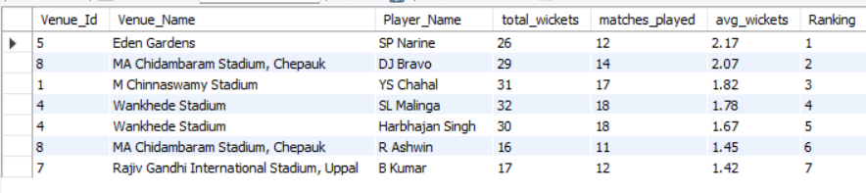
This output displays each bowler's average wickets per match across various venues, with bowlers ranked by performance. The Wicket_Rank column enables quick identification of top-performing bowlers based on average wickets per match at each venue.

14. Which of the given players have consistently performed well in past seasons? (will you use any visualisation to solve the problem)

Table Name | Purpose | Key Columns Used in Query
Player | Stores player details. | Player_Id, Player_Name
Ball_by_Ball | Records every delivery in a match. | Match_Id, Over_Id, Ball_Id, Innings_No, Striker, Bowler, Runs_Scored
Wicket_Taken | Records wickets taken on specific balls. | Match_Id, Over_Id, Ball_Id, Innings_No, Player_Out
Matches | Holds match-level details. | Match_Id, Season_Id
Season | Stores season information. | Season_Id, Season_Year
To identify players who have consistently performed well over past seasons, based on their average runs scored and average wickets taken per season.
Required Tables:

Query Strategy:

Step 1: Build Player_Season_Performance (CTE)
- Join Player → Ball_by_Ball Links each player to deliveries where they were either the striker (batting) or bowler (bowling).
- Join Wicket_Taken (LEFT JOIN) Matches deliveries to wickets taken (same Match_Id, Over_Id, Ball_Id, Innings_No). → Counts dismissals for each player.
- Join Matches → Season Connects each delivery to its season via Season_Id.
- Aggregate by Player_Name + Season_Year
  - SUM(Runs_Scored) → Total runs per season.
  - COUNT(wt.Player_Out) → Total wickets per season.
  - COUNT(DISTINCT m.Match_Id) → Matches played per season.
Step 2: Final Selection
- Aggregate across seasons
  - AVG(Total_Runs) → Average runs per season.
  - AVG(Total_Wickets) → Average wickets per season.
  - COUNT(Season_Year) → Number of seasons played.
- Filter
  - HAVING Seasons_Played > 3 → Only consistent players across 4+ seasons.
- Order
  - Sort by batting strength first (Avg_Runs_Per_Season DESC), then bowling (Avg_Wickets_Per_Season DESC).
- Limit
  - Top 10 players.

Query:
WITH Player_Season_Performance AS (
SELECT
p.Player_Name,
s.Season_Year,
SUM(bbb.Runs_Scored) AS Total_Runs,
COUNT(wt.Player_Out) AS Total_Wickets,
COUNT(DISTINCT m.Match_Id) AS Matches_Played
FROM Player p
INNER JOIN Ball_by_Ball bbb ON p.Player_Id = bbb.Striker
LEFT JOIN Wicket_Taken wt ON bbb.Match_Id = wt.Match_Id
AND bbb.Over_Id = wt.Over_Id
AND bbb.Ball_Id = wt.Ball_Id
AND bbb.Innings_No = wt.Innings_No
INNER JOIN Matches m ON bbb.Match_Id = m.Match_Id
INNER JOIN Season s ON m.Season_Id = s.Season_Id
WHERE p.Player_Id = bbb.Bowler OR p.Player_Id = bbb.Striker
GROUP BY p.Player_Name, s.Season_Year
)
SELECT
Player_Name,
AVG(Total_Runs) AS Avg_Runs_Per_Season,
AVG(Total_Wickets) AS Avg_Wickets_Per_Season,
COUNT(Season_Year) AS Seasons_Played
FROM Player_Season_Performance
GROUP BY Player_Name
HAVING Seasons_Played > 3
ORDER BY Avg_Runs_Per_Season DESC, Avg_Wickets_Per_Season DESC
LIMIT 10;

Output:
The query output presents the top 10 players with consistently high average runs and average wickets across seasons. Each player’s performance is evaluated based on their average runs per season and average wickets per season, along with the number of seasons they’ve played, giving insight into their consistency and contribution to the team's success.

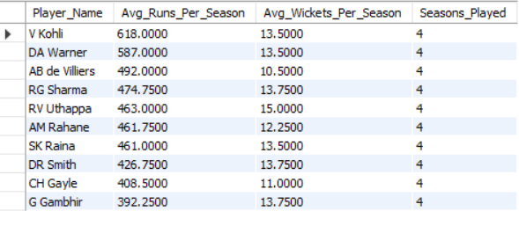

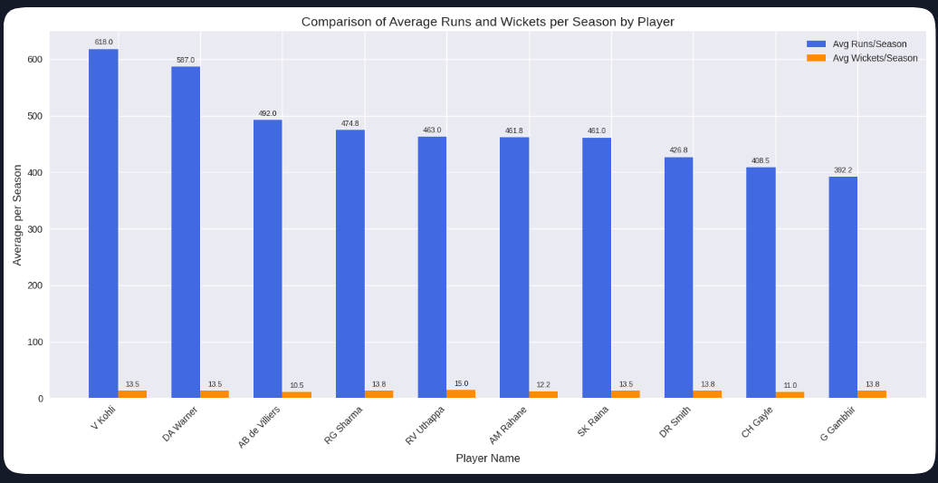

15. Are there players whose performance is more suited to specific venues or conditions? (how would you present this using chart?)

To determine if certain players perform better in specific venues or under particular conditions. This information can help teams strategize by selecting players who excel in given environments.

Required Tables:
- player: Contains player details, including Player_Id and Player_Name.
- ball_by_ball: Provides ball-level data for each match, identifying both striker and bowler.
- wicket_taken: Logs details of wickets taken, including the player who got out.
- matches: Holds information on each match, including venue details.
- venue: Contains venue-specific data, with Venue_Id and Venue_Name.

#Batting performance

Query:
SELECT p.Player_Name, v.Venue_Name,
SUM(b.Runs_Scored) AS Total_Runs,
COUNT(b.Ball_Id) AS Balls_Faced,
ROUND(SUM(b.Runs_Scored) / COUNT(b.Ball_Id), 2) * 100 AS Strike_Rate
FROM Ball_by_Ball b
JOIN Matches m ON m.Match_Id = b.Match_Id
JOIN Player p ON p.Player_Id = b.Striker
JOIN Venue v ON m.Venue_Id = v.Venue_Id
GROUP BY p.Player_Name, v.Venue_Name
HAVING Total_Runs > 0 AND Balls_Faced > 100
ORDER BY Total_Runs DESC, p.Player_Name;

Output:

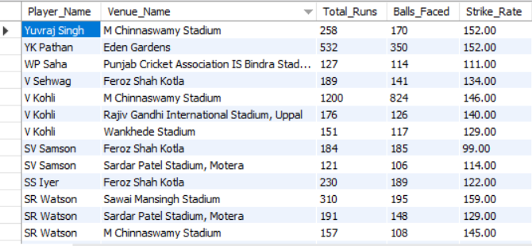
🏟️ Analysis of Venue-Specific Performance

Venue Specialists
- AB de Villiers – M Chinnaswamy Stadium (967 runs, SR 170) Explosive at RCB’s home ground, thrives on short boundaries.
- AD Russell – Eden Gardens (SR 176) Highest strike rate overall, perfect finisher in Kolkata’s batting-friendly conditions.
- SK Raina – Wankhede Stadium (SR 173) Aggressive middle-order hitter, best suited for Mumbai’s flat pitch.
- SR Watson – Sawai Mansingh Stadium (SR 159) Strong hitter in Jaipur conditions.
- KA Pollard – Wankhede Stadium (646 runs, SR 155) Death overs specialist, thrives in Mumbai.
- MS Dhoni – Chepauk (468 runs, SR 146) Classic finisher, thrives in Chennai’s slower conditions.
- CH Gayle – Chinnaswamy (963 runs, SR 146) vs Ranchi (SR 90) Explosive in Bangalore, struggles in slower conditions.

Balanced Contributors
- V Kohli
  - Chinnaswamy → 1200 runs, SR 146
  - Uppal → 176 runs, SR 140
  - Wankhede → 151 runs, SR 129 Insight: Kohli adapts across venues, but is most dominant at Chinnaswamy.
- RG Sharma
  - Wankhede → 832 runs, SR 142
  - Eden Gardens → 270 runs, SR 144
  - Kotla → 176 runs, SR 134 Insight: Rohit is consistent, strongest at Wankhede.
- SK Raina
  - Wankhede → SR 173 (finisher)
  - Chepauk → SR 127 (anchor role)
  - Eden Gardens → SR 111 (conservative) Insight: Role changes with venue — aggressive in Mumbai, stabilizer in Chennai/Kolkata.

Venue-Dependent Players
- S Dhawan – Uppal (SR 111) → Anchor role, less suited for high-scoring venues.
- G Gambhir – Eden Gardens (SR 118) → Conservative opener, stabilizer role.
- SV Samson – Kotla (SR 99) → Struggles in Delhi conditions.
- M Vijay – Chepauk (SR 96) → Struggles in Chennai compared to Mohali.

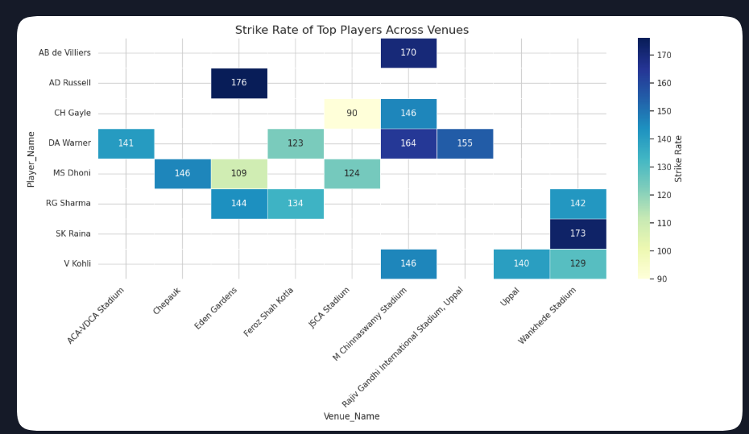

This heatmap is the best way to present the analysis in a report — it visually highlights which players are best suited to specific venues or conditions.
- Explosive hitters (Russell, AB de Villiers, Raina, Pollard) thrive in batting-friendly venues.
- Anchors (Dhawan, Gambhir, Rahane) perform better in slower conditions.
- Venue-dependent players (Gayle, Samson, Vijay) show sharp contrasts in performance.

#Bowling performance

Query:

SELECT p.Player_Name, v.Venue_Name,
COUNT(w.Player_Out) AS Wickets_Taken,
COUNT(b.Ball_Id) AS Balls_Bowled
FROM ball_by_ball b
JOIN wicket_taken w ON b.Match_Id = w.Match_Id
AND b.Over_Id = w.Over_Id AND b.Ball_Id = w.Ball_Id AND b.Innings_No = w.Innings_No
JOIN matches m ON m.Match_Id = w.Match_Id
JOIN player p ON p.Player_Id = b.Bowler
JOIN venue v ON m.Venue_Id = v.Venue_Id
GROUP BY p.Player_Name, v.Venue_Name
HAVING Balls_Bowled > 5
ORDER BY Wickets_Taken DESC,p.Player_Name;

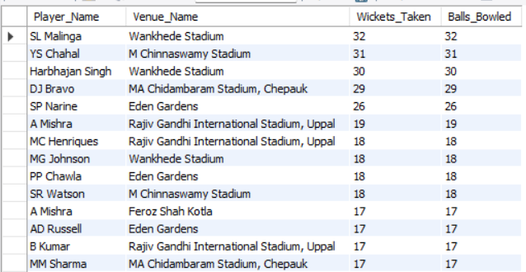
Output:

🏟️ Venue-Specific Bowling Specialists.

Pace Specialists
- SL Malinga – Wankhede Stadium (32 wickets)
  - Known for deadly yorkers, thrives under lights in Mumbai’s batting-friendly ground.
  - His success here shows how pace bowlers with variations can dominate even on batting tracks.
- MG Johnson – Wankhede Stadium (18 wickets)
  - Left-arm pace, effective bounce and swing.
- JJ Bumrah – Wankhede Stadium (9 wickets)
  - Death overs specialist, complements Malinga’s style.
Insight: Wankhede favours fast bowlers who can bowl yorkers and slower balls in death overs.

Spin Specialists
- YS Chahal – M Chinnaswamy Stadium (31 wickets)
  - Leg-spin specialist, thrives despite short boundaries.
  - Shows how attacking spin can succeed even in batting-friendly venues.
- SP Narine – Eden Gardens (26 wickets)
  - Mystery spin, highly effective on turning tracks.
- PP Chawla – Eden Gardens (18 wickets)
  - Leg-spin, consistent wicket-taker.
- R Ashwin – Chepauk (16 wickets)
  - Classic off-spinner, thrives in Chennai’s slow pitch.
Insight: Spin-friendly venues (Chepauk, Eden Gardens, Kotla) consistently reward spinners with control and variations.

All-Rounder Bowlers
- DJ Bravo – Chepauk (29 wickets)
  - Slower balls, cutters, and variations suit Chennai’s slower pitch.
  - Also effective at Eden Gardens (8 wickets) and Wankhede
(8 wickets).
- SR Watson – Chinnaswamy (18 wickets)
  - Medium pace and cutters are effective in Bangalore.
  - Also contributes at Motera (7 wickets) and Sawai Mansingh
(6 wickets).
- AD Russell – Eden Gardens (17 wickets)
  - Pace + power, effective in Kolkata conditions.
Insight: All-rounders adapt across venues, but their best performances align with pitches that suit their bowling style.

Venue-Dependent Bowlers
- A Mishra – Uppal (19 wickets) vs Kotla (17 wickets)
  - Strong in spin-friendly venues, less effective elsewhere.
- RA Jadeja – Chepauk (8 wickets) vs Kotla (6 wickets)
  - More effective in Chennai’s spin conditions.
- UT Yadav – Kotla (17 wickets) vs Eden Gardens (7 wickets)
  - Pace effectiveness varies depending on pitch.

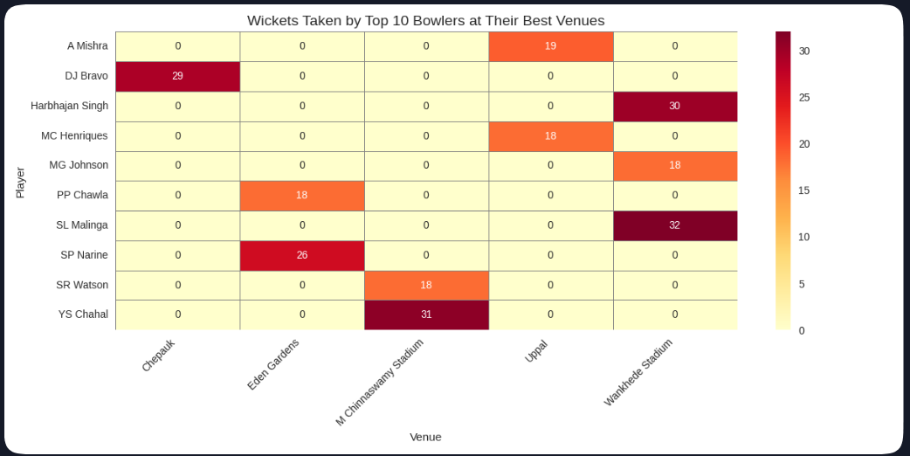

This visualisation is ideal for presentations — it instantly shows which bowlers are best suited to specific venues or conditions, helping in auction and match strategy.

- Venue specialists exist: Malinga (Wankhede), Chahal (Chinnaswamy), Bravo (Chepauk), Narine (Eden Gardens).
- Spin-friendly venues (Chepauk, Eden Gardens, Kotla) reward spinners like Ashwin, Mishra, Narine.
- Pace-friendly venues (Wankhede) reward yorker specialists like Malinga, Johnson, and Bumrah.

